# Week 4 QUIZ – Enhancing Scatterplots

## Question 1

Parte superior do formulário

**This scatterplot shows the relationship between the Body Mass Index (BMI) and Age of people from the NHANES-1000 dataset.**

**Select the technique that would be most useful in giving us more insight into the BMI data.**

Make the points semi-transparent.

Colour the points by **Age**.

Add a straight trend line.

Decrease the size of the symbols.

**Add a smoother and running quartiles.**

**Correct**

This statement is **TRUE**. A smoother is designed to be flexible and fit the data in a variety of shapes. It will summarise the trend curve and other quantiles will add information about what is happening in the scatter.

Parte inferior do formulário

## Question 2

**The following statements refer to this plot of Age and Weights of people from the NHANES-1000 dataset.**

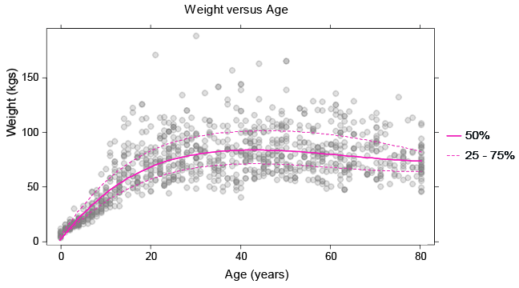

One of the statements is false. Select the **FALSE** statement.

The darker patches in the plot are places where the data is more dense.

**Jittering would help us see more of the values that are overprinted in this graph.**

A linear trend ‘curve’ would not fit this data very well.

The curved pink line gives us an idea of what the average weight is for a given age.

About 25% of the 40 year-olds weigh more than 100kgs.

Correct

This statement is **FALSE**. Jittering is a useful technique for seeing if there are a lot of values sitting directly on top of one another. We already know this with the use of transparency.

Parte inferior do formulário